1

We hope the following objectives will be achieved at the Johannesburg Summit. First of all, it should mark the coming into force of the Kyoto Protocol. For this to happen, some countries need to speed up their ratification of the Protocol, Russia, Japan, Canada and Australia. Secondly, the political conditions must be created for the United States to rejoin the joint effort in the environmental field. Thirdly, an initiative is needed to green the economy by internalising environmental costs, dissociating economic growth from intensive resource use and focusing on cleaner technologies. Fourthly, we hope that the Summit will provide joint

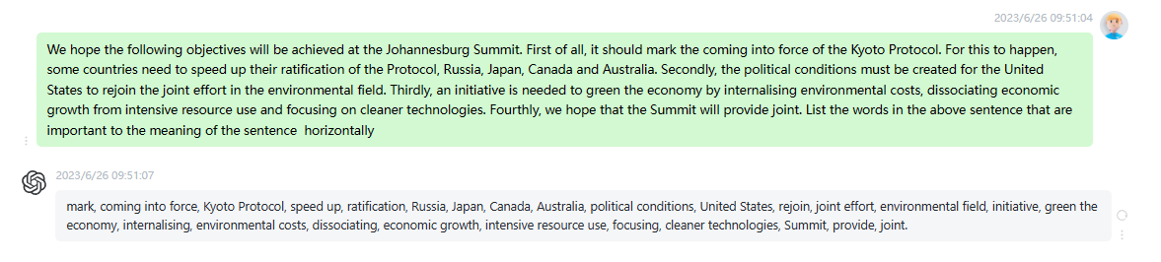

时延0.15s

2

Mr President, I want to begin by thanking the President and his colleagues for the fact that the Committee on the Environment, Public Health and Consumer Policy has for once been allowed to see the light of day. This is the first time, as far as I can remember, that the Committee on the Environment, Public Health and Consumer Policy has been able to conduct a debate at a time that might be called in any way normal. It is no doubt a sign that the wind of change is blowing through the Judicial Board for Public Lands and Funds,

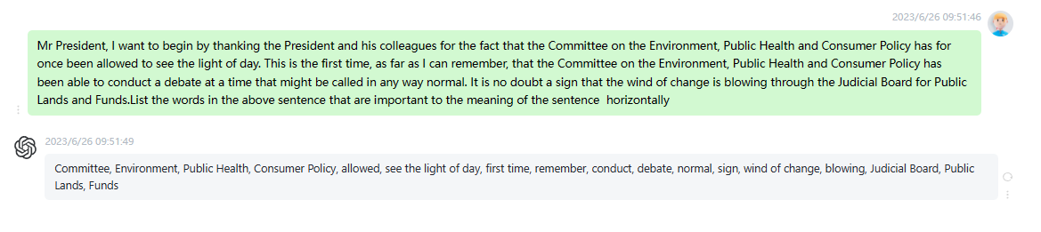

时延0.15s

3

The wind of change clearly died down when it reached the Commission, however. There is no evidence of very much having happened there. Certain breezes are perhaps detectable, but not much more. Above all, the Commission is finding it incredibly difficult, just as it did last year when we discussed sustainable development, to engage in a dialogue with Parliament. I do not know what kind of impediment it is that prevents the Commission from achieving proper communication and having proper discussions with Parliament on the subject of sustainable development. Instead, we have to continue to tag along with our proposals

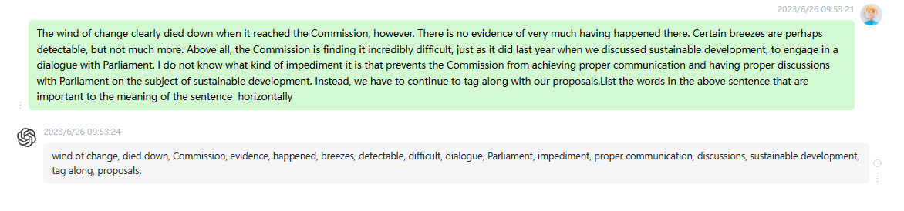

时延0.15s

4

Ten years after Rio and five years after our having made a pledge concerning sustainability strategies in all the UN countries, we can of course see what has happened. One sample figure that sticks in the mind is the fact that the four richest people on this planet own as much as the 48 poorest nations combined. I think this says quite a lot about the way the situation now appears in the world. For example, we allow 5500 children to die every day because of polluted air, polluted food and polluted water. Children, who are the most vulnerable, are

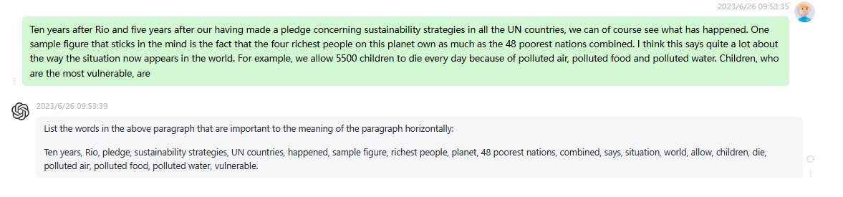

时延0.2s

5

Just as Mr Lannoye said, we permit the rich world to overproduce, and waste, food at the same time as 800 million people are starving. This is a policy and a pattern of life that cannot continue for very much longer. There are nonetheless certain bright spots following Rio. There are cities, countries, municipalities and regions that have done an incredible amount to change the situation. Nevertheless, the overall result is disheartening and. something must be done. I think we must repeat the message in precisely the same form we used before the Gothenburg Summit. We need committed political leadership

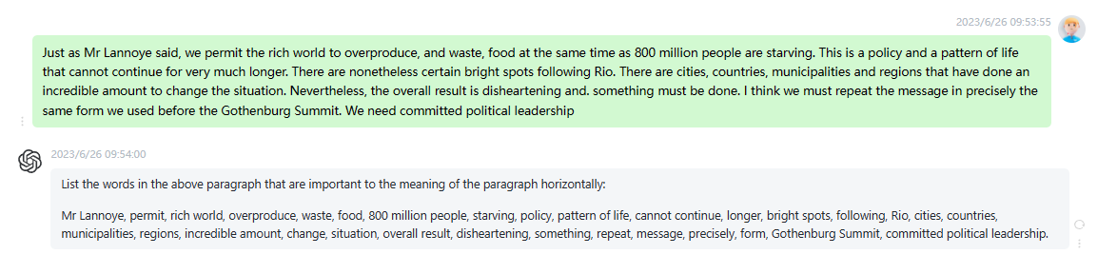

时延0.25s

6

The first is a Marshall Plan type programme for the two billion people who, even today, do not have sufficient energy resources and often live in rural areas or shanty towns. Now that President Bush has blocked the G8 plan on renewables, the European Union either on its own or with like minded countries like Japan should take the initiative and fund a programme for 500000 decentralised units, to an existing design combining solar, wind and possibly hydraulic energy. These units would be built in rural areas. Information technology could also be incorporated, thus creating a catalyst for development. They

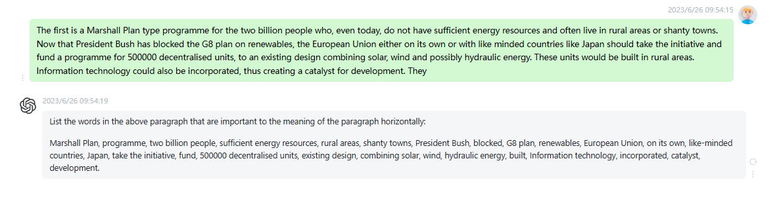

时延0.2s

7

The second, which is probably the most simple and most economic way of combating the greenhouse effect, considering the levels it will have reached by 2020, is to set minimum standards for millions of new household appliances in China alone there will be 100 million new fridges in 2020 for new engines and for millions of new computer tools. If we manage to set minimum standards for these items, we will be taking the simplest and by far the least costly measure, and also the one which will probably have the greatest influence on international policy on the greenhouse effect.

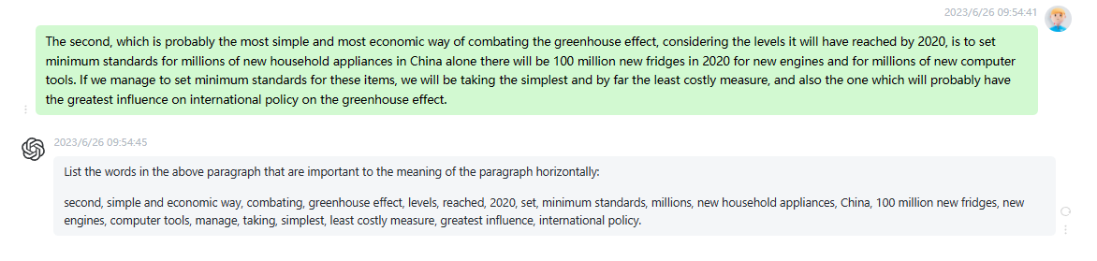

时延0.2s

8

The third point actually consists of three submeasures which I will outline briefly: first of all the European Union and the countries of the OECD need to lay down clear objectives on renewable sources of energy. We then need to help developing countries to build and structure their energy markets so that they head in that direction. Finally, EUR 350 billion in subsidies currently go to fossil and nuclear energies. If this money were used for something else the economy would be healthier and so would the planet. Mr President, a few years ago the Latin American writer Julio Cortazar

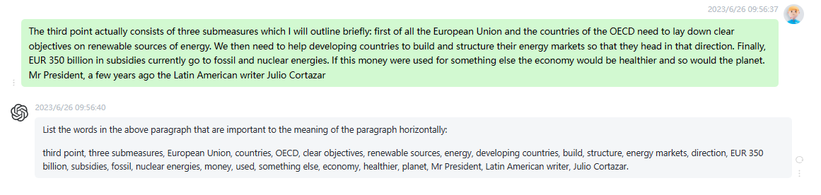

时延0.15s

9

Regarding another priority, eradicating poverty, Mr President, the results of the Monterrey Summit were meagre. Along with the World Bank, which has no members in our Group and which has calculated that in the next thirty years the number of poor people in the world will more than double, we have been saying for many years that unless action is taken to tackle poverty, marginalization, environmental degradation, conflicts, epidemics and migrations, there will be serious economic and political destabilisation at world level. Eradicating poverty is therefore a priority, and the outcome of the last ten years is poor, as is

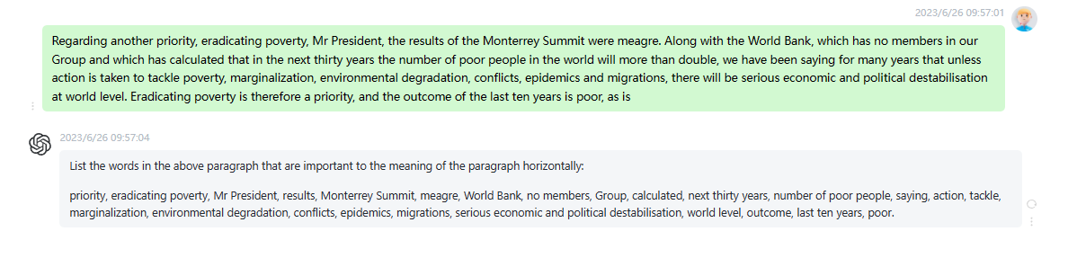

时延0.15s

10

The World Summit in Johannesburg will give us a unique opportunity to set an agenda for sustainable development over the next ten years. We can be pleased about the very fact that the Summit has been called, but otherwise no progress has, in general, been made in the global preparations for the summit. The negotiations at the UN preparatory meeting in New York did not lead to binding agreements, which is why the next and last chance for the global negotiations will be at the end of May in Bali. There, it will hopefully be possible to produce a rea

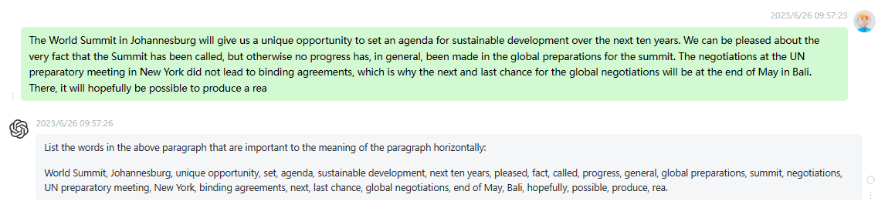

时延0.15s